Name: _____________________ Date: ________ Period ____
Evolution J. Bhalla Powerpoint
Charles Darwin and the Galapagos Islands (1835):
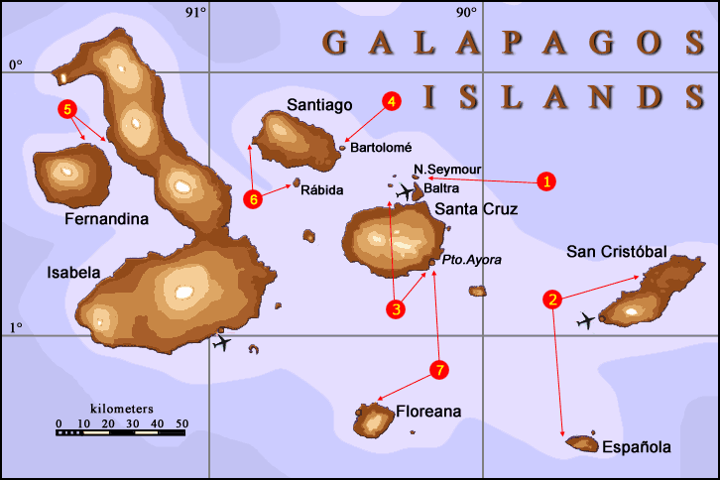
- Darwin sailed from ________________________________ and then to the Galapagos Islands.
- Darwin compared the species he observed in S. America to the species in the Galapagos. The differences _______________
__________________________________________________.
- Also, within the Islands of the Galapagos, there was a great
difference between ________________________________ (sea level vs. mountainous region).
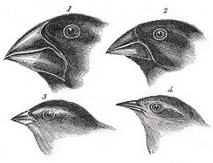
Darwin’s Finches Observe the beaks of the Finches:
The beak of each finch is adapted to…______________________________________
1.Birds that have a strong, wide beak are adapted for eating… __________

2.Birds that have a sharp, needlelike beak are adapted for eating… ________

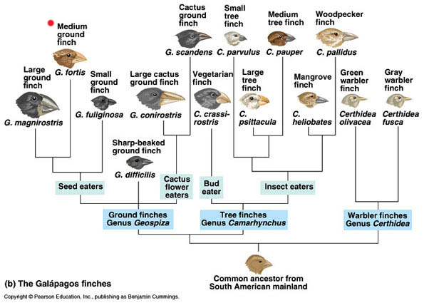
What is an adaptation?
An adaptation is _____________________________________________________________________________.
It is also the evolution of a structure, behavior, or internal process that enables an organism to ______________
__________________________________________________________________________________________ .
Ex. TIGER (list some adaptations): __________________________________________________________
What did Darwin theorize?
Darwin returned to England and spent the next 20 years trying to figure out ________________________
____________________________________________________________________________________
Darwin reasoned that _______________________that arrived on one of the Galapagos Islands faced
___________________________________________________________________________________________.
Darwin believed the species gradually changed over many generations and became better adapted to the new conditions.

Theory of Evolution
Gradual ___________________________________________________________________________________
So…How could this process of SELECTIVE BREEDING happen in nature?
______________________________:
The process by _______________________________________________________________________
___________________________________________________________________________________.
How does Natural Selection occur?
- ___________________________________: Individuals that are better suited for ______________________
___________________________________________________________________________________________.
- __________________, natural selection results in ________________________________________ of a

population. These changes _________________________________________________________________
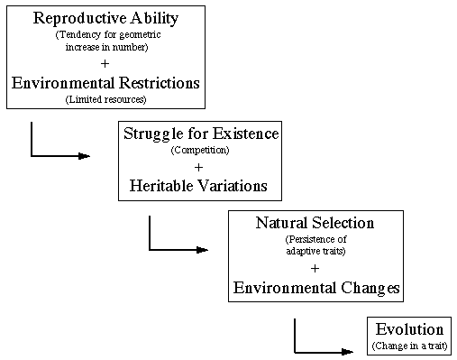
What affects natural selection?
The driving force behind evolution is the interactions between
____________________ and their _____________________ .
Darwin identified four factors that affect the process of natural
selection: _________________________, __________________,
_____________________________________, and
____________________________ among individuals…
1. Overproduction
Most species produce ___________________________________________
SO
there are NOT enough _________________________________________
so
many offspring ______________
so
Population remains the ___________________________________________

-Those species that produce many offspring guarantee that a few will survive to a reproductive age.
-Overproduction is an adaptation for many species for survival.
Ex. FROGS :

2. Competition
- When food and other resources are limited, ________________________________________________.

- The _______________________________(fastest runner, strongest wings) will survive to produce offspring.

- Those that are weak (unable to get food) ______________________________________________________.

3. Environmental Conditions
- When __________________________________________________________, those species that are

___________________________to the new environment will survive to reproduce.
- Example: Peppered Moths of England during the Industrial Revolution.
- Example: Kaibab and Albert Squirrel – Grand Canyon
  - The species are believed to have been the same species thousands of years ago. When the Grand Canyon formed, it created a geographic barrier within the population. This eventually led the species to evolve, and now mating cannot occur between the two species.
(switch to Powerpoint part 2 Slides 20 – 47)
4. Variations
- _________________________: Any difference in traits between _______________ of the same species

***Over a long period of time, ____________________________accumulate in a species, while

________________________________________.

- Without______________________, all the members of a species would have the same traits. Evolution by natural selection would not occur because all individuals would have an ____________________________________________________________________________.
ANY TRAIT THAT HELPS AN ORGANISM SURVIVE AND REPRODUCE IS SAID TO HAVE AN ADAPTIVE VALUE.

Remember….this was the 1800s!
Darwin did not know anything about genes or mutations, so he could not explain what caused variations or how they were passed on, but today, we know two major sources of Variations:
1. “___________________________________” – random assortment of genes during meiosis and fertilization.

2.___________________________: (change in the normal DNA sequence)
- Nearly all mutations are harmful, but a few mutations can be beneficial to the survival of the organism
Example: Polar Bears - The allele for fur without color would not be a beneficial adaptation unless the animal lived in an area where the fur would match the environment.

Evidence of Evolution (MEMORIZE THESE 5 FACTS!!)

Evidence #1: _____________________

FOSSILS: ___________________________________________________________________________________

Most fossils form when organisms that die become ________________________________.
* The older the fossil, the deeper it would be buried

Calculating the Age of Fossils
Most fossils are found in ________________________that was formed at the ___________________________.
Sediments are formed when water flows over land and wear away (erodes) the land. These sediments then

settle to the bottom of the river. They eventually___________ (due to the pressure on them) into __________.

____________________________________: the higher up you go in an undisturbed rock stratum, the younger the rock layers become. ** Upper, undisturbed strata generally contain fossils of more complex organisms, whereas, the lower strata contain fossils of simpler life forms. (Tendency toward increasing complexity over time.) ** When comparing fossils in undisturbed strata, fossils can be found in upper strata which, although different from fossils in lower strata, resemble those fossils. This suggests links between modern forms and older forms, as well as divergent pathways from common ancestors.
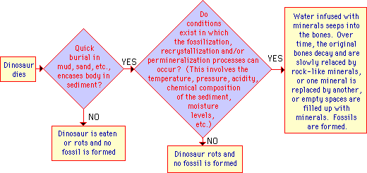
How to Date Fossils
- ______________________________- used to tell which of two fossils is older (looking at the rock layers)

2. _______________________________- measuring the radioactive elements in the fossils (gives an actual age)

Interpreting the fossil Record (Relative Dating)

_________________________ – relating fossils to specific areas and rock layers

_________________________ – fossils which existed in a relatively short period of time and over large area

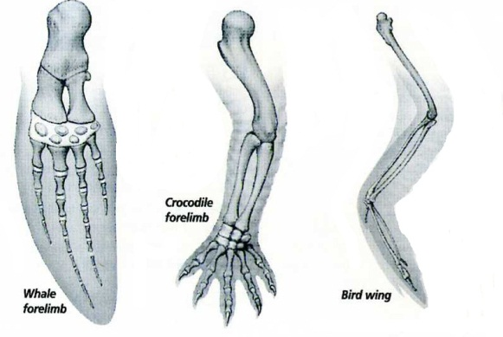
_________________________ – divides time into eons, eras, periods, and epochs

Evidence #2: ______________________

________________________________: Body parts that are alike in structure or function because the species in question share a common ancestor. Ex: Whale, crocodile, bird, human
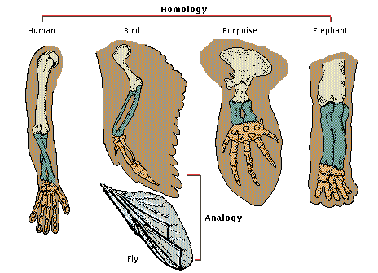

______________________________
- Structures with________________ structures but serve the ____________________________ Suggests different lines of evolution, meaning they came from MANY ORGANISMS!
Ex: wing of an insect and the wing of a bird
- Both wings are used for flying, but they are made of completely different materials.
Evidence #3: __________________________

____________________________________________________________________________________

Comparative Embryology

Fish Salamander Tortoise Chick Calf Human
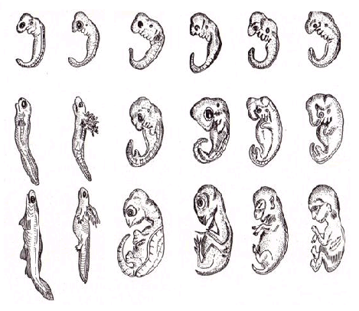

Evidence #4: _________________________

- _____________________________________ same four Nitrogenous Bases (A, T, G, C)

- Proteins in all organisms are made from the __________________________________.

Evidence #5: ________________________________

__________________________________________________________________________________________
Examples:
  - whale pelvis
  - tiny snake pelvic and limb bones
  - the eyes in cave-dwelling salamanders and fish that are completely blind

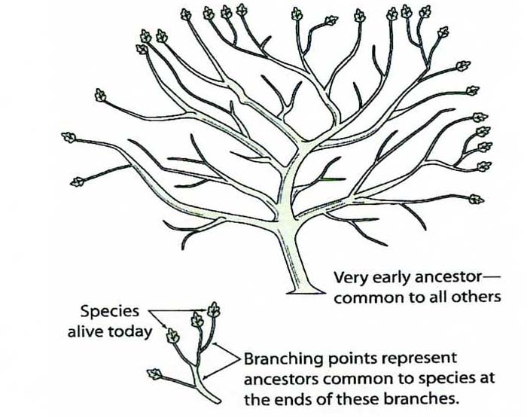
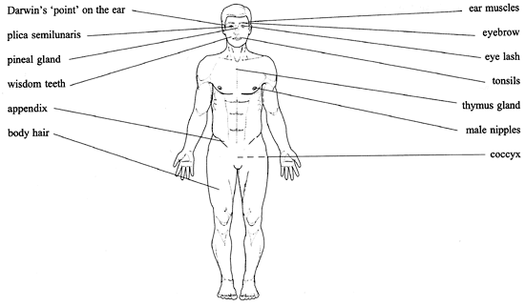
Vestigial Structures in Humans
What is extinction?
- Extinction: _______________________________
_______________________________________ .
- Extinction occurs when the DEATH RATE is greater than the BIRTH RATE within a given species.
- Extinction is most likely to occur when there is a ___________________________________________
- Examples:___________________________________________________________________________
_________________________________________________________________________________________ .
